ASP (Ayumi, Shinji, Puneet’s) Belgian Waffles
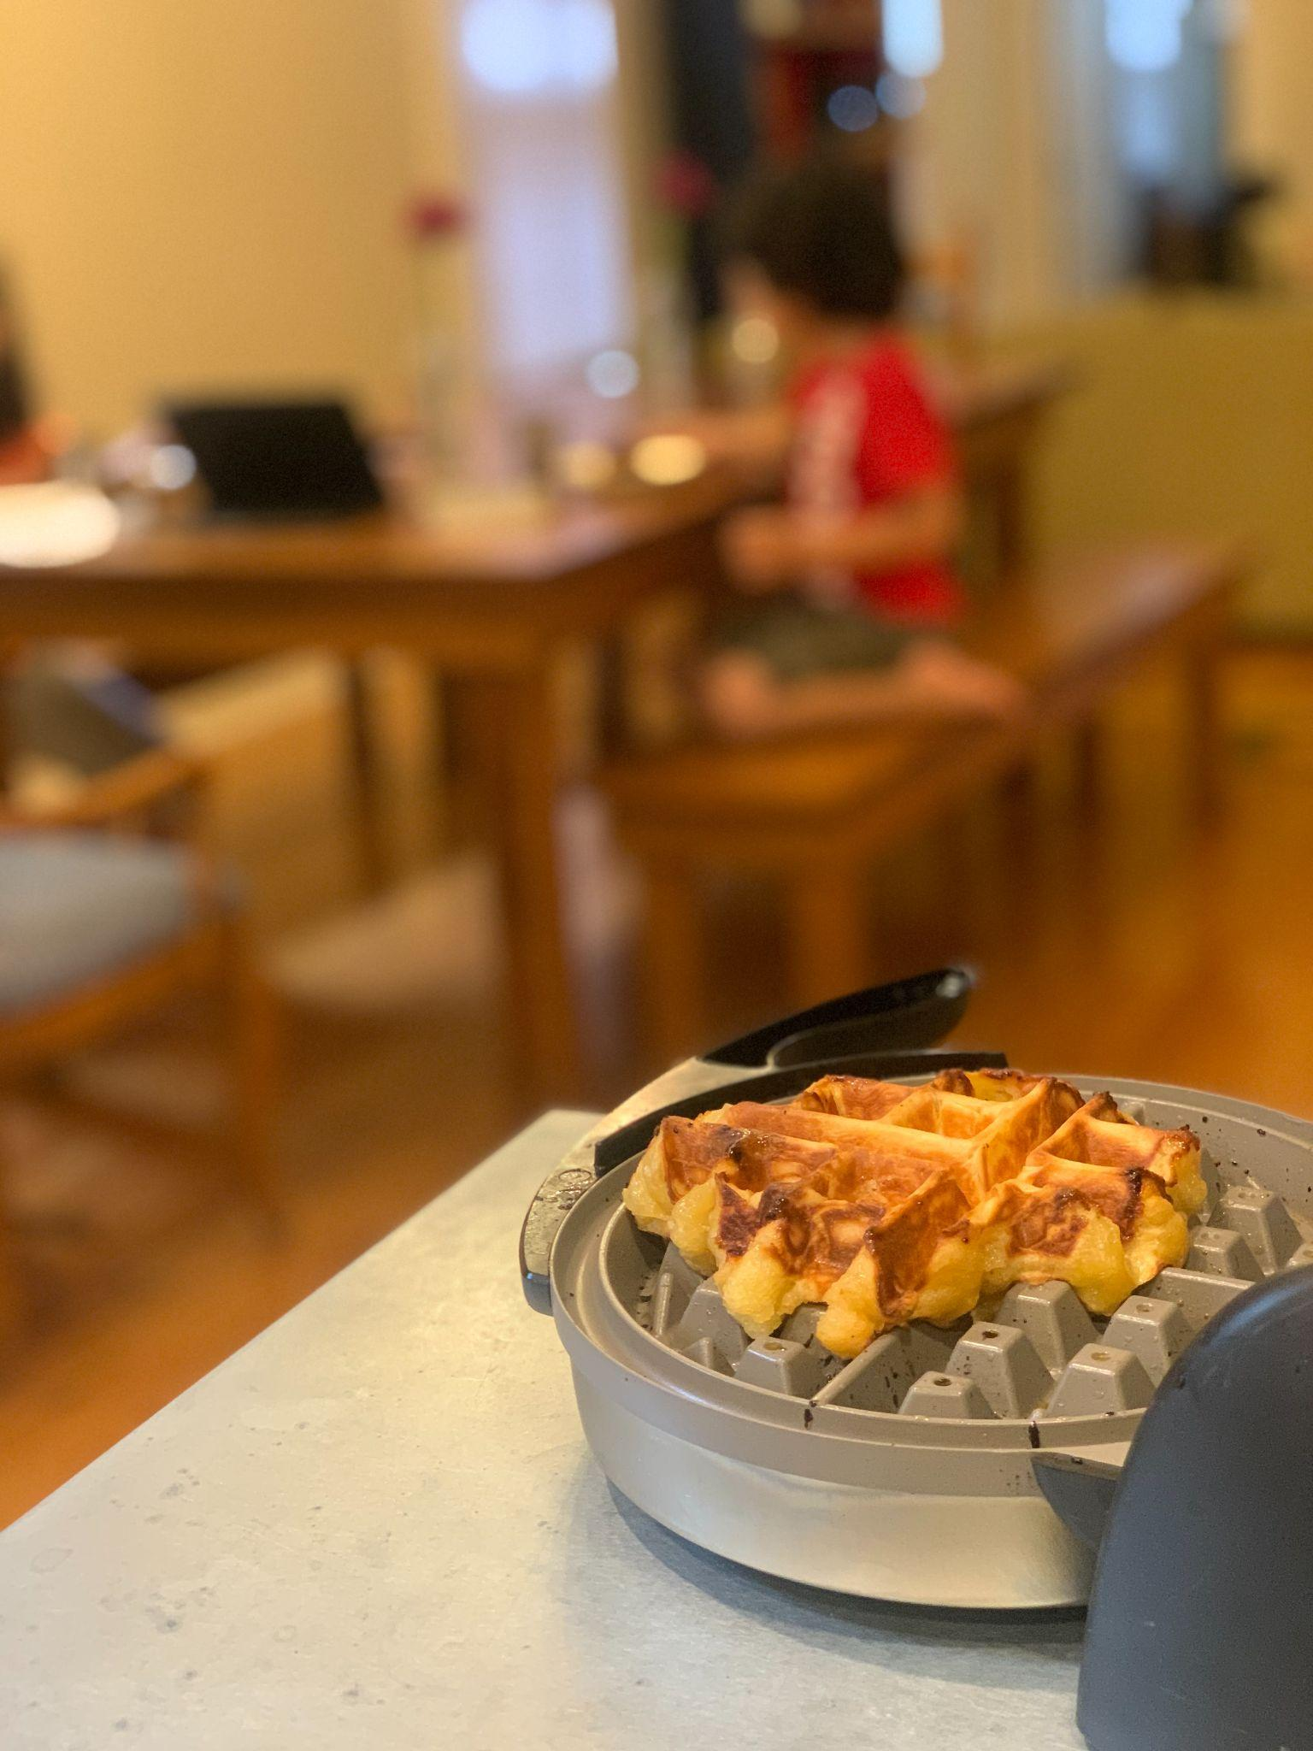

2/17/2021
.36 oz instant yeast (was a lot, waffles were much fluffier -- not as good)
Beat eggs in warm/hot butter.
Didn’t mix the pearl sugar too much, which caused a lot of burned caramelization on the outside (not as good)

2/6/2021
1 cup butter, ¾ milk, .2 oz instant yeast (not active), beat eggs in butter
Came out great! Didn’t double in size tho

https://www.allrecipes.com/recipe/213251/liege-belgian-waffles-with-pearl-sugar/

1 (.25 ounce) package active dry yeast OR .2 oz instant yeast
1 1/2 tablespoons white sugar
3/4 cup lukewarm milk
3 eggs
1 cup melted butter
2 teaspoons vanilla extract
3 cups flour
1/2 teaspoon salt
1 1/2 cups pearl sugar (such as Lars' Own®)

[Sprinkle the yeast and white sugar over warm milk in a small bowl. The milk should be no more than 100 degrees F (40 degrees C). Let stand for 15 minutes until the yeast softens and begins to form a creamy foam.]

Whisk the eggs, melted butter, and vanilla extract into the yeast mixture until evenly blended; set aside. Stir together the flour and salt and instant yeast [if using] in a separate large bowl, and make a well in the center. Pour the egg mixture into the well, then stir in the flour mixture until a soft dough forms. Cover with a light cloth and let rise in a warm place (80 to 95 degrees F (27 to 35 degrees C)) until doubled in volume, about 30 minutes. Gently mix in the pearl sugar.
Preheat a waffle iron according to manufacturer's instructions.
Place a baseball-size ball of dough on the preheated waffle iron. Cook waffles until golden and crisp, about 2 minutes. Repeat with remaining dough. Allow waffles to cool for 2 to 3 minutes before serving.

NOTES
8/17
1 cup butter, 1.5 cups pearl sugar was toooooo much

8/2/2020
3/4 butter
2 cardomom pods into egg mix

2/2020:
wax paper sucks. Parchment paper rules
freezes well

best just to go with cup butter and 1 cup sugar.

1/19/2020:
this recipe makes 6 small waffles.
3/4 cup butter
3/4 cup milk at 115, 1.5 tbsp sugar for yeast -- beautiful
3 tsp vanilla
wax paper to wrap dough for later
remember to mix pearl sugar evenly (which is difficult)

12/15/2020:
pearl sugar matters
1 cup is good
1 cup melted butter is good

12/20/2020:
1/2 cup pearl sugar didn't work out well
1/2 cup melted butter also too little

12/24/2019
1 cup pearl sugar
1 cup melted butter
wrapped some balls of dough for later use, totally fine!

